Welcome to NHS Highland
Chronic Pain Management Service

Important: Your referral to the Chronic Pain Management Service cannot be processed until this completed questionaire is returned to your GP’s Surgery.

Information from this questionnaire helps us to understand your pain problem better. It is important that you read each question carefully and answer as best you can. There are no right or wrong answers. Please try to answer every question. If in doubt, please select the answer which most closely describes your situation.

Name: Date:

DOB: Sex: M / F

Telephone Nº: Mobile:

GP: Dr Health Centre:

(Admin use only – GP VERSION May 2010)

- What would you like to achieve by coming to the pain clinic?

- How long have you had your pain?

- How did it start?

- Has your pain changed over time?

Better
Same
Worse

- Describe your pain.

- Draw on the picture to show where your worst pain(s) are. Feel free to write on the drawing if this would help using the symbols below to shade the areas.

Numbness Pins & Needles Ache Pain
========= xxxxxxxxxxxxxx oooo ////

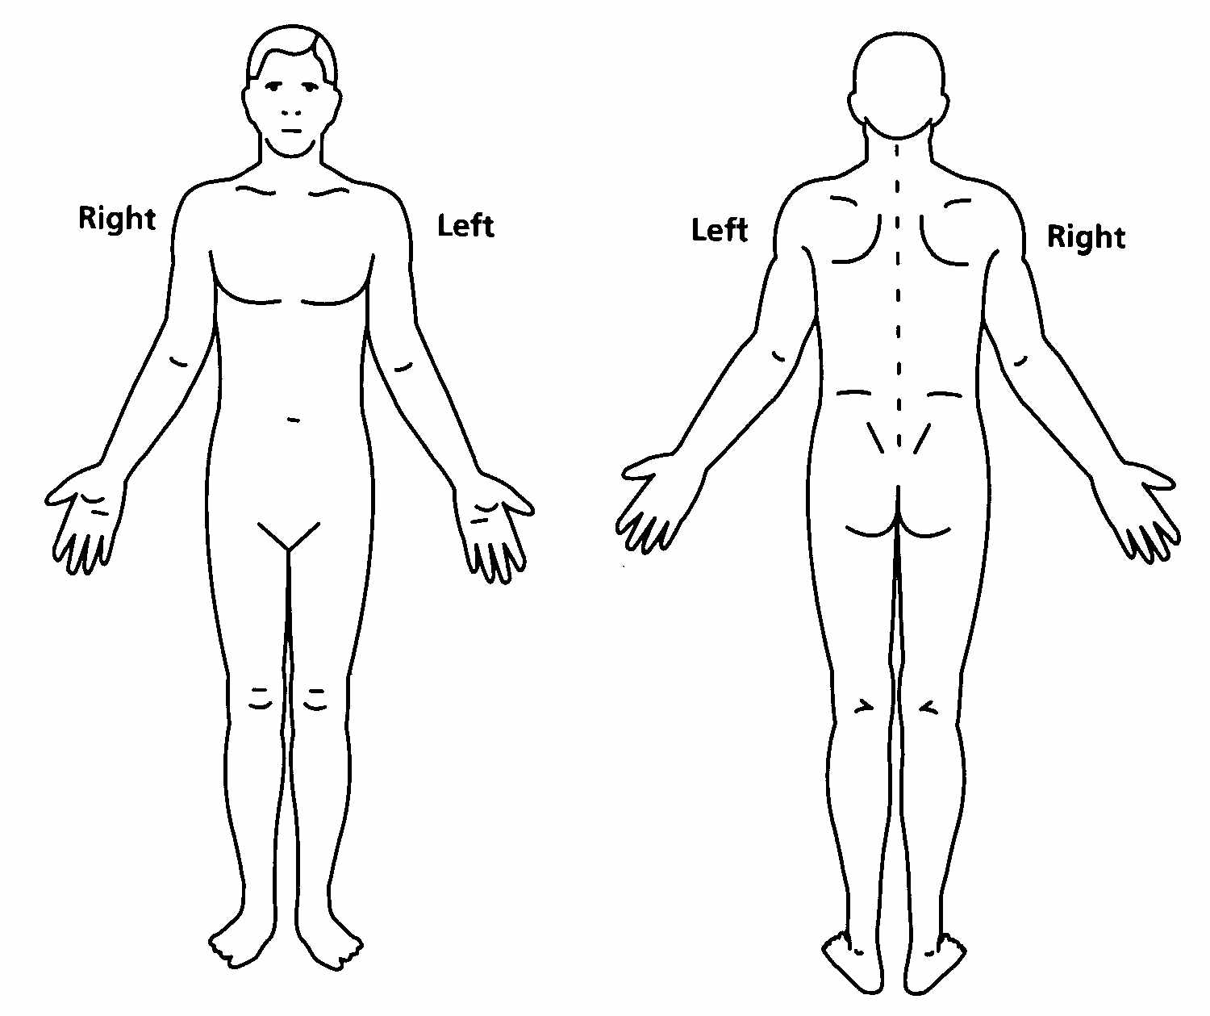

- What do you think is causing your pain?

- What investigations have you had for the pain (e.g. x-rays, scans, blood tests, nerve tests)? Please give dates and the hospital if possible

- What treatments for pain other than medication are you having now, or have you tried in the past? Tick all of the boxes that apply. Have any of the treatments helped?

Past | Now | Treatment | Helpful?
 |  | Physiotherapy | Y / N
 |  | Acupuncture | Y / N
 |  | TENS | Y / N
 |  | Chiropractic | Y / N
 |  | Osteopathy | Y / N
 |  | Homeopathy | Y / N
 |  | Herbal Remedies | Y / N
 |  | Hypnosis | Y / N
 |  | Psychology | Y / N

- Do you suffer from any other medical condition not related to the pain?

- Do you have any allergies? (e.g. Elastoplasts, Antibiotics)

- Are you currently seeing any other specialist? If yes, please state the hospital and clinic.

Yes / No

- Do you need help to look after yourself because of your pain? If, yes, what help do you need?

- Do you need to use aids or appliances (e.g. wheelchair, crutches, walking stick, back support) because of the pain? If yes please give details.

Yes / No

- To what extent have the following areas of your life been affected by your pain?

Job | Not at all Very much  1 2 3 4 5
Friends | Not at all Very much  1 2 3 4 5
Family Life | Not at all Very much  1 2 3 4 5
Social Life | Not at all Very much  1 2 3 4 5
Hobbies | Not at all Very much  1 2 3 4 5
Exercise | Not at all Very much  1 2 3 4 5

- Do you have a job?

Yes / No

If Yes, what is it: Full time / Part-time
To what extent does your pain affect your work?

If No, is this as a result of your pain?

- Are you receiving or in the process of claiming any state benefits (e.g. unemployment, invalidity, disability, mobility, etc.)? If yes please give details.

- Have you sought legal advice or made any claim on account of your pain problem?

Yes / No

If yes, please give details.

- What questions would you like to ask about your pain?

- What worries you about your pain

- What medicines have you tried in the past for your pain? Did they help? (Current medication to be recorded on the next page)
Medication Record

Please list all medicines that you take at the same time each day.

Date Started | Name of Medicine | Recommended dose and instructions | What dose do you take? | What is it for?

Please list below any other medication that you take including any that your doctor has asked you to take when needed.

Date Started | Name of Medicine | Recommended dose and instructions | What dose do you take? | What is it for?

Your Physical Health
This survey asks for your views about how your pain now affects how you function in everyday life. This information can help you and your pain team know how you feel and how well you are able to do your daily tasks at this time.
Please answer every question by circling one number between 0 and 10 with ‘0’ meaning pain does not interfere and ‘10’ meaning pain interferes severely.

BE SURE TO ANSWER ALL QUESTIONS

- Does your pain interfere with your normal work inside and outside the home?

Work normally 0 1 2 3 4 5 6 7 8 9 10 Unable to work at all

- Does your pain interfere with personal care (Such as washing, dressing, etc)?

Take care of 0 1 2 3 4 5 6 7 8 9 10 Need help with all
myself completely my personal care

- Does your pain interfere with your travelling?

Travel anywhere 0 1 2 3 4 5 6 7 8 9 10 Only travel to see
I like Doctors

- Does your pain affect your ability to sit or stand?

No problems 0 1 2 3 4 5 6 7 8 9 10 Cannot sit/stand at all

- Does your pain affect your ability to lift overhead, grasp objects or reach for things?

No problems 0 1 2 3 4 5 6 7 8 9 10 Cannot do at all

- Does your pain affect your ability to lift objects off the floor, bend, stoop or squat?

No problems 0 1 2 3 4 5 6 7 8 9 10 Cannot do at all

- Does your pain affect your ability to walk or run?

No problems 0 1 2 3 4 5 6 7 8 9 10 Cannot walk/run at all

- Has your income declined since your pain began?

No decline 0 1 2 3 4 5 6 7 8 9 10 Lost all income

- Do you have to take pain medication every day to control your pain?

No medication 0 1 2 3 4 5 6 7 8 9 10 On pain medication
needed throughout the day

- Does your pain force you to see doctors much more often than before your pain began?

Never see doctors 0 1 2 3 4 5 6 7 8 9 10 See doctors weekly

- Does your pain interfere with your ability to see the people who are important to you as much as you would like?

No problem 0 1 2 3 4 5 6 7 8 9 10 Never see them

- Does your pain interfere with recreational activities and hobbies that are important to you?

No interference 0 1 2 3 4 5 6 7 8 9 10 Total interference

- Do you need the help of your family and friends to complete everyday tasks (including both work outside the home and housework ) because of your pain?

Never need help 0 1 2 3 4 5 6 7 8 9 10 Need help all the
time

- Do you now feel more depressed, tense or anxious than before your pain began?

No depression/ 0 1 2 3 4 5 6 7 8 9 10 Severe depression/
tension tension

- Are there emotional problems caused by your pain that interfere with your family, social or work activities?

No problems 0 1 2 3 4 5 6 7 8 9 10 Severe problems

Here are some things that other patients have told us about their pain. For each statement please circle any number from 1 to 4 to indicate whether you agree or disagree with the statement.

 | Strongly Disagree | Somewhat Disagree | Somewhat Agree | Strongly Agree
- I’m afraid that I might injure myself if I exercise | 1 | 2 | 3 | 4
- If I were to try to overcome it, my pain would increase | 1 | 2 | 3 | 4
- My body is telling me I have something dangerously wrong | 1 | 2 | 3 | 4
- My pain would probably be relieved if I were to exercise | 1 | 2 | 3 | 4
- People aren’t taking my medical condition seriously | 1 | 2 | 3 | 4
- My accident has put my body at risk for the rest of my life | 1 | 2 | 3 | 4
- Pain always means I have injured my body | 1 | 2 | 3 | 4
- Just because something aggravates my pain doesn’t mean it is dangerous | 1 | 2 | 3 | 4
- I am afraid I might injure myself accidentally | 1 | 2 | 3 | 4
- Simply being careful that I do not make any unnecessary movements is the safest thing I can do to prevent my pain from worsening | 1 | 2 | 3 | 4
- I wouldn’t have this much pain if there weren’t something dangerous going on in my body | 1 | 2 | 3 | 4
- Although my condition is painful, I would be better off If I were physically active | 1 | 2 | 3 | 4
- Pain lets me know when to stop exercising so that I do not injure myself | 1 | 2 | 3 | 4
- It’s really not safe for a person with a condition like mine to be physically active | 1 | 2 | 3 | 4
- I can’t do all the things normal people do because it’s too easy for me to get injured | 1 | 2 | 3 | 4
- Even though something is causing me a lot of pain, I don’t think it’s actually dangerous | 1 | 2 | 3 | 4
- No one should have to exercise when he/she is in pain | 1 | 2 | 3 | 4

Clinicians are aware that emotions play an important part in most illnesses. If we know about these feelings, we may be able to help you more. This questionnaire is designed to help us to know how you feel. Read each statement and place a tick in the box opposite the answer that comes closest to how you have been feeling in the past week. Don’t take too long over your replies: your immediate reaction will probably be more accurate than a long thought out response.
I feel tense or ‘wound up’- |  |  | I feel as if I am slowed down -
Most of the time…………………………….. |  |  | Nearly all the time…………………………
A lot of the time…………………………….. |  |  | Very often……………………………………..
Occasionally…………………………………… |  |  | Sometimes…………………………………….
Not at all………………………………………… |  |  | Not at all………………………………………..

I still enjoy the things I used to - |  |  | I get a sort of frightened feeling, like …‘butterflies’ in the stomach -
Definitely as much………………………….. |  |  | Not at all………………………………………..
Not quite so much………………………….. |  |  | Occasionally…………………………………..
Only a little…………………………………….. |  |  | Quite often…………………………………….
Hardly at all……………………………………. |  |  | Very often……………………………………..

I get a sort of frightened feeling as if something awful is about to happen - |  |  | I have lost interest in my appearance -
Very definitely and quite badly………. |  |  | Definitely……………………………………….
Yes, but not too badly…………………….. |  |  | I don’t take as much as I should…….
A little, it doesn’t worry me……………. |  |  | I may not take quite as much care…
Not at all………………………………………… |  |  | I take as much care as I ever did…….

I can laugh and see the funny side of things - |  |  | I feel restless as if I have to be on the ….move -
As much as I always have……………….. |  |  | Very much indeed………………………….
Not quite so much now………………….. |  |  | Quite a lot……………………………………..
Definitely not so much now……………. |  |  | Not very much……………………………….
Not at all………………………………………… |  |  | Not at all………………………………………..

Worrying thoughts go through my mind - |  |  | I look forward with enjoyment to things -
A great deal of the time………………….. |  |  | As much as I ever did……………………..
A lot of the time……………………………… |  |  | Rather less than I used too…………….
From time to time………………………….. |  |  | Definitely less than I used to………….
Only occasionally……………………………. |  |  | Hardly at all……………………………………

I feel cheerful - |  |  | I get sudden feelings of panic -
Not at all………………………………………… |  |  | Very often indeed………………………….
Not often……………………………………….. |  |  | Quite often…………………………………….
Sometimes…………………………………….. |  |  | Not very often……………………………….
Most of the time…………………………… |  |  | Not at all………………………………………..

I can sit and feel quite relaxed - |  |  | I can enjoy a good book, radio or TV ….programme -
Definitely……………………………………….. |  |  | Often……………………………………………..
Usually…………………………………………… |  |  | Sometimes…………………………………….
Not often……………………………………….. |  |  | Not often……………………………………….
Not at all………………………………………… |  |  | Very seldom…………………………………..

Pain Rating Scales (5th Vital Sign)
Please mark the scale below to show how intense your pain is. Mark one number only.
A zero (0) means no pain, and ten (10) means extreme pain.
 | How intense is your pain now?
No Pain |  |  |  |  |  |  |  |  |  |  |  | Extreme pain
 | 0 | 1 | 2 | 3 | 4 | 5 | 6 | 7 | 8 | 9 | 10

 | How intense was your pain on average last week?
No Pain |  |  |  |  |  |  |  |  |  |  |  | Extreme pain
 | 0 | 1 | 2 | 3 | 4 | 5 | 6 | 7 | 8 | 9 | 10

Now please use the same method to describe how distressing you pain is.

 | How distressing is your pain now?
Not at all  distressing |  |  |  |  |  |  |  |  |  |  |  | Extremely  Distressing
 | 0 | 1 | 2 | 3 | 4 | 5 | 6 | 7 | 8 | 9 | 10

 | How distressing was your pain on average last week?
Not at all  distressing |  |  |  |  |  |  |  |  |  |  |  | Extremely Distressing
 | 0 | 1 | 2 | 3 | 4 | 5 | 6 | 7 | 8 | 9 | 10

Now please use the same method to describe how much your pain interferes with your normal everyday activities.

Does not interfere |  |  |  |  |  |  |  |  |  |  |  | Interferes completely
 | 0 | 1 | 2 | 3 | 4 | 5 | 6 | 7 | 8 | 9 | 10

How easy was it to complete this questionnaire?

  - Easy
  - Fairly easy
  - Difficult
  - Very difficult

How detailed did you find this questionnaire?

  - Not detailed enough
  - Just right
  - Too detailed
  - Far too detailed

Thank you for completing this questionnaire.

